  Name: | ___________________________________________________ |  | Date: ___________
 | Year 11 Applications  Test 3, 2016  Topics – Perimeter, Area, Surface Area and Volume |  | 32  = %
Total Time: | 50 minutes
Total Reading: | 5 minutes
Total Working: | 45 minutes
Weighting: | 4% of the year,8% of the semester.
Equipment: | SCSA Formula Sheet; 1 page notes (A4 one side, Unfolded), CASIO ClassPad; Scientific Calculator

1. | [4 marks: 1, 1, 2]
 | Calculate the perimeter of the following shapes:
a) | 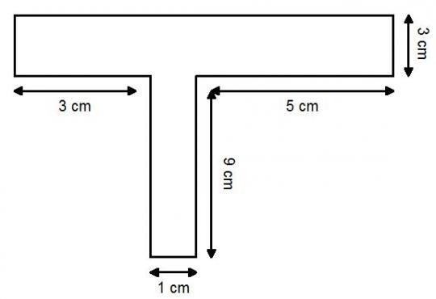 |  | b) | 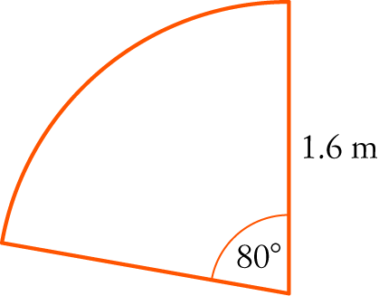
c) | 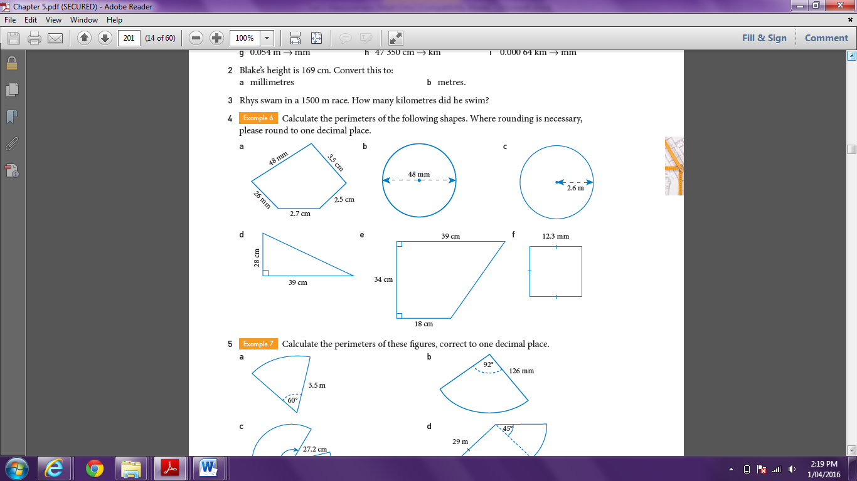
2. | [5 marks: 1, 2, 2]
 | Calculate the area of the following shapes:
a) | 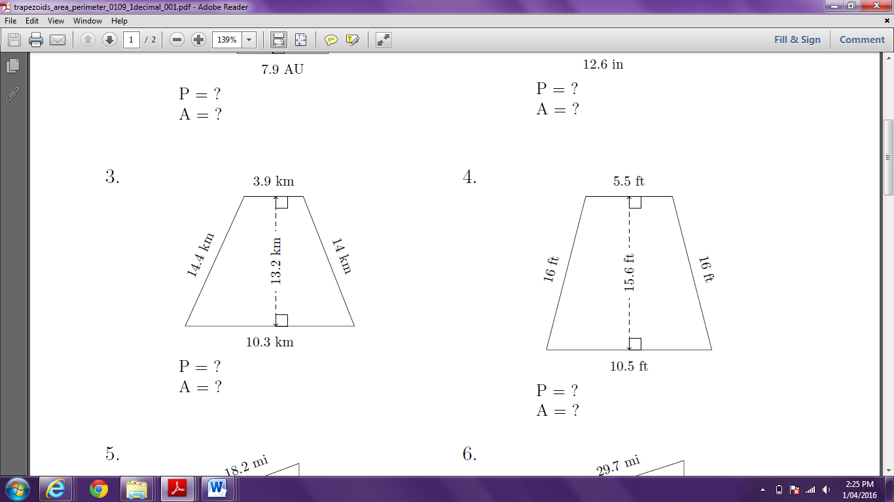 |  | b) | 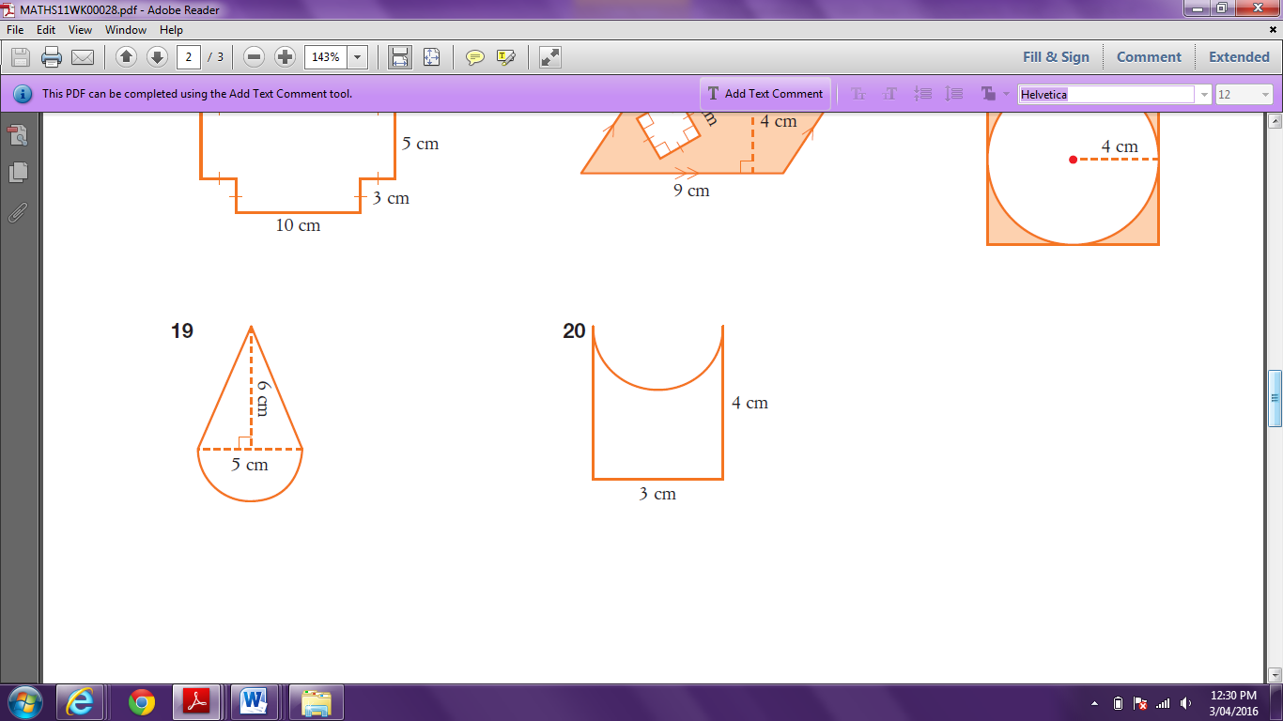
c) | 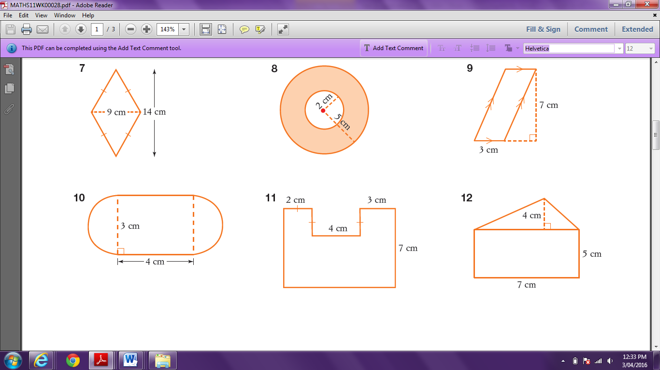
3. | [1 mark]
 | The volume of the solid shown could be found using which calculations?
 | 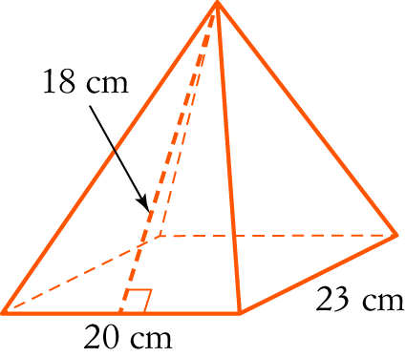 | A × 20 × 23 × 18  B × 20² × 18  C × 23² × 13.8  D × 20 × 23 × 13.8  E 20 × 23 × 13.8
3. | [4 marks: 2, 2]
a) | Find the surface area and volume of the following 3D solids:  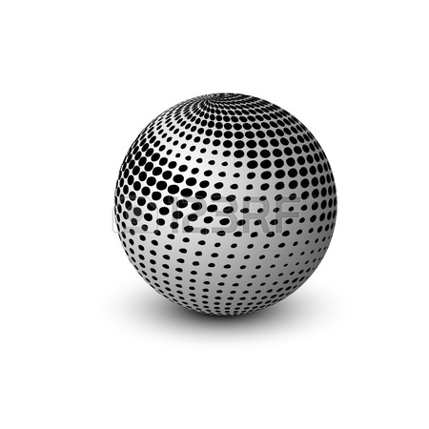  d = 17.3 cm
b) | 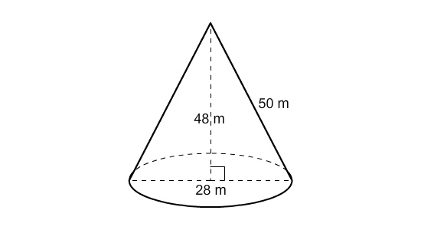
4. | [3 marks]
Cans of soup are often packed in boxes as shown below. Calculate the area that is wasted in between all of the cans.
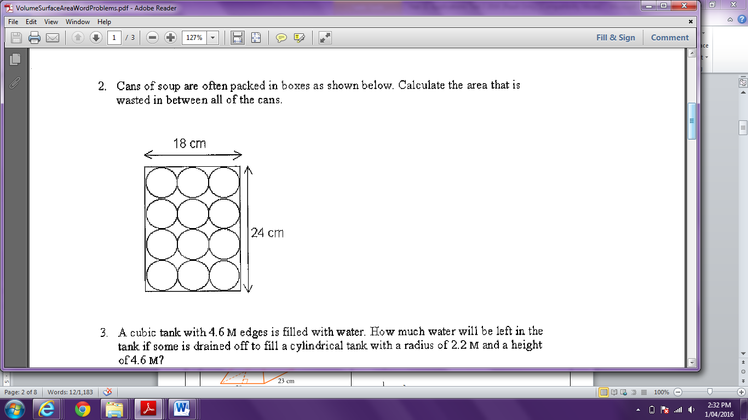

5. | [3 marks: 2, 1]
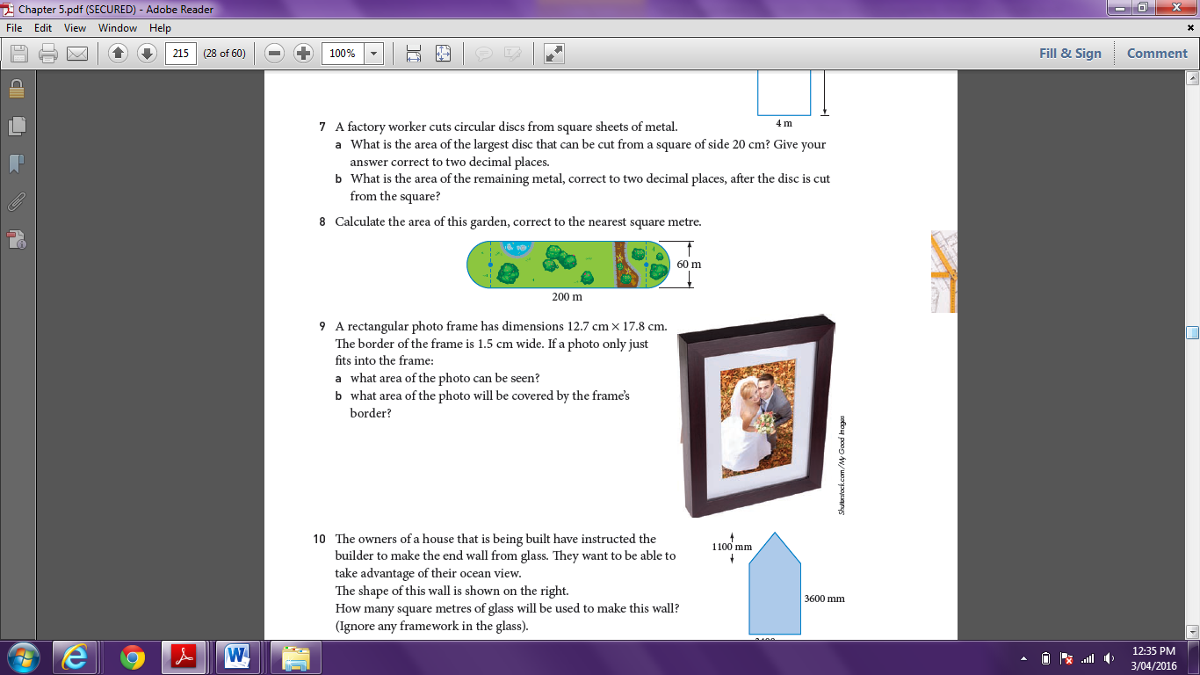
A rectangular photo frame has dimensions 12.7cm x 17.8 cm.
The border of the frame is 1.5 cm wide.
If a photo only just fits into the frame:

a) | What area of the photo can be seen?
b) | What area of the photo will be covered by the frame’s border?
6) | [2 marks]
If the volume of a cube is 27cm³, what is the surface area of the cube? (Show all working)
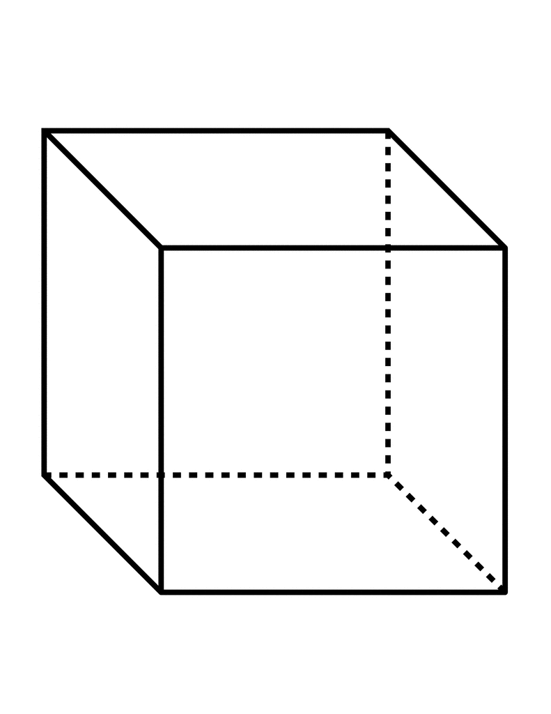

7. | [3 marks]
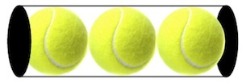
Three identical tennis balls with an 8cm diameter are stacked in a cylindrical container. Calculate the surface area and volume of the inside of this container.

8. | [3 marks]
The James family have the rain water tank shown below. What is the volume of the James’ tank in cubic metres, correct to one decimal place? How many Litres of water can it hold?

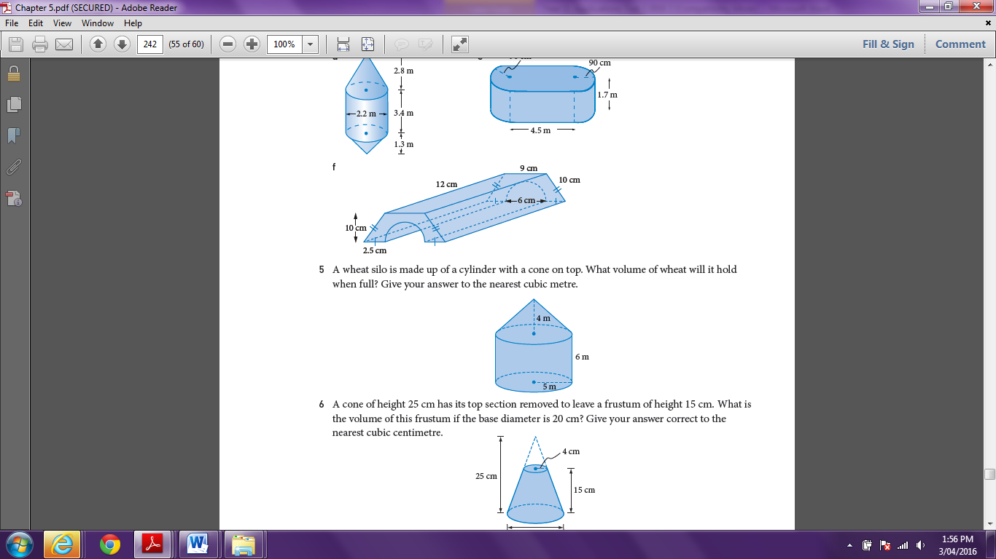

9. | [2 marks]
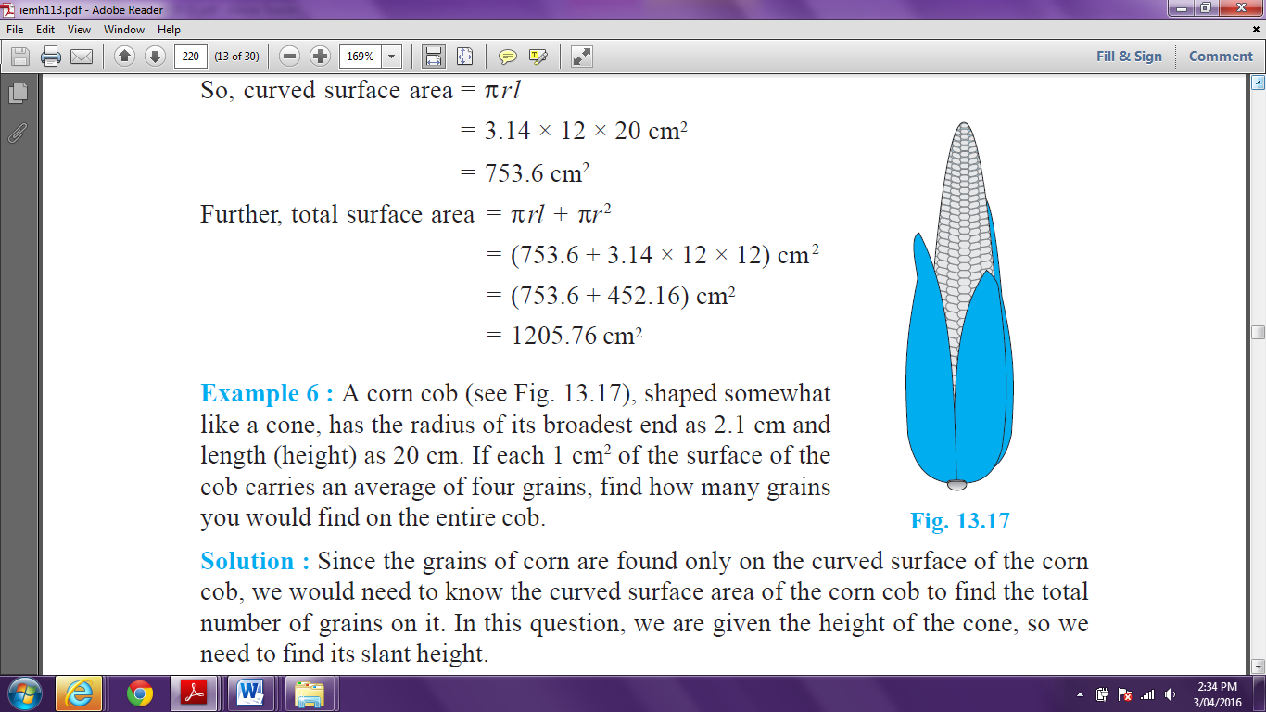
A corn cob, shaped like a cone, has a radius of 2.1cm and a slant height of 20.11cm. If each 1cm² of the surface of the cob carries an average of four corn kernels, how many corn kernels would you expect to find on the entire cob of corn?

10. | [2 marks]
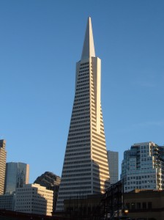
The Transamerica Pyramid in San Francisco is shaped like a square pyramid. It has a slant height of 260.9 metres and each side of its base has a length of 44.2 metres. Find the lateral area of the building.
Remember: lateral area of a solid is the area of any face or surface that is not a base.

~ END OF TEST ~

